Kirin Harrington

18harringtonk@utcsheffiield.org.uk

Abstract

8/9/2021

Level 2 Interactive media.

Unit 1

Contents

Introduction 7

Interactive media – product research 7

App 7

Games 8

Virtual reality 8

Websites 9

Social media 10

Health and safety 11

Repetitive Strain Injury (RSI) 11

Symptoms 11

Prevention 11

Risk when producing an interactive media product 12

Eye stain/Headaches 12

Symptoms 12

Prevention 12

Upper/Lower Back pain 13

Symptoms: 13

Prevention 13

Risk when producing an interactive media product 14

Leg/Foot strain 14

Symptoms 14

Prevention 15

Risk when producing an interactive media product 15

Target audience 16

Gender 16

Age 17

Income 18

Location 19

Lifestyle 20

Accessibility 21

Game case study 22

Website case study 23

App case study 23

Features 25

WhatsApp 25

Target audience 25

YouTube 25

Target audience 26

First Bus 27

Target audience 27

Subway surfers 28

Target audience 28

Beat saber 29

Target audience 29

Creative processes 30

Storyboards 30

Mood-boards 30

Extension: Linking with previous sections, Computer related Health and Safety 32

Scripts 33

Sources of information 34

Types of sources 34

Primary source 34

Secondary source 34

Tertiary source 34

Data vs Information 34

Primary, Secondary or Tertiary? 34

Sources for projects 35

Internet 35

Books 35

Technical manuals 35

Magazines 35

Newspapers 35

Techniques 36

Websites 36

Website 37

Example – Wikipedia 37

Game 37

Example – Minecraft 38

Interactive presentation 38

Example – Museum presentation 38

App – fitness tracker 38

Example – Strava 39

Linking 39

Navigation buttons, links, menus: 39

Hit counters, leader boards, help-sections: 39

Game levels, multimedia, power-ups: 39

Additional skills 40

Literacy skills 40

LO2 41

Design basics 41

Colour 41

Backgrounds 41

Buttons 41

Logos 41

Themes/Colour Schemes 42

Monochromatic 42

Analogous 42

Complementary 43

Split complementary 43

Picking colours 44

An interactive information display at a museum: 44

An interactive informational display for people with poor eyesight. 45

Fonts and typefaces 45

Sans vs Sans Serif 45

Whitespace 46

Good uses of white space: 46

Bad uses of white space: 47

House Style 47

Colours 47

Editing images 50

G.I.M.P 50

Paint.Net 50

Adobe Photoshop 50

Instagram 51

Website authoring 54

Notepad 54

Brackets 54

3D modelling 58

Interactive presentation 62

Hardware experimentation 66

School PC 66

Phone hardware 67

Peripherals 67

Mouse 67

Unused hardware 68

Macro keys 68

Dual monitors 68

A graphics card 69

Optimised mouse 69

More cores 69

LO3 70

Image manipulation 70

Website authoring 72

3D modelling 74

Interactive presentations 76

Portfolio software 77

Microsoft word 77

PowerPoint 79

Pros 79

Cons 79

Alternatives 79

Photoshop 80

Pros 80

Cons 80

Alternatives 80

Brackets 81

Pros 81

Cons 81

Alternatives 81

Blender 82

Pros 82

Cons 82

Alternatives 82

Publisher 83

Pros 83

Cons 83

Alternatives 83

Self AND PEER REVIEWS 84

iMAGE MANIPULATION 84

positives 84

Negatives 84

wEBSITE DEVELOPMENT 85

positives 85

Negatives 85

3d MODELLING 85

positives 85

Negatives 85

iNTERACTIVE PRESENTATIONS 86

positives 86

Negatives 86

Peer review 87

Image manipulation 87

Interactive presentations 87

Future applications of feedback 87

Skills comparison 88

Potential improvments 89

# Introduction

# Interactive media – product research

Here are some examples of interactive media.

## App

Short for application, are pieces software that can be installed on a range of electronic devices, I.E computers, tablets, and smartphones. Apps perform an extensive range of tasks, anywhere for shopping, messaging, gaming and even dating.

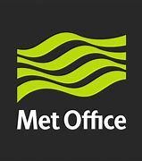The most popular app to inform you about the weather.

<https://www.metoffice.gov.uk/weather/forecast/uk>



An app which allows you to order food from local restaurants and chains and then delivers it to your house.

https://www.deliveroo.co.uk/

## Games

Can be for entertainment or education. Online games can be a great way to relive stress and connect with friends in a community, education games can be a helpful tool to encourage students to enjoy learning and speed up progress.

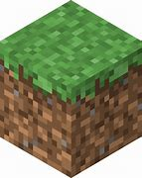

The iconic symbol for

The hugely popular game

Minecraft.

<https://minecraft.com/>



Space invaders, a very old arcade style game which was at the height of technology at its release.

## Virtual reality

A truly amazing result of technology. Making you feel emersed in your own virtual world and allowing you to interact, move and experience pretty much anything. Virtual reality can be used for gaming, allowing for an infinitely better experience because it allows for a fully immersive experience. Virtual reality can also be used for exercise that can transport you to stunning scenery while you complete your exercise. It can even be used in a professional environment allowing you to take apart structural models and experiment without it influencing the real world.

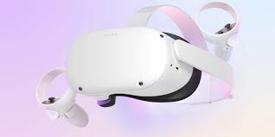This is an image of the popular VR headset, the Oculus Quest.

<https://www.oculus.com/>

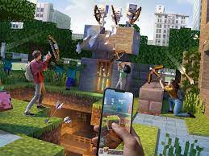

This is an AR game called Minecraft earth which is very similar to a VR in the sense that they both create a simulated reality. However, AR used the world around you and adds to it whereas VR creates a completely new reality.

## Websites

Websites are a series of webpages which you can swap between that are accessed through the internet. They are usually used to convey information, allowing for a huge well of knowledge at everyone’s fingertips. Websites have become so easy to create through tools that people have programmed that anyone can create their own website, fill it with whatever they want, buy a domain, and publish it to the internet.

There can be quite a large crossover between apps and websites as some of the most popular websites creating their own apps. Here is an example of one. Amazon, which is arguably the most popular shopping website. <https://amazon.com/>

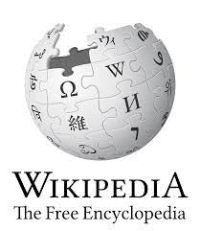

This is Wikipedia, A huge source of information due to its thousands of web pages which are all created by a community and allows for information about basically any topic no matter how little known.

[Wikipedia, the free encyclopaedia](https://en.wikipedia.org/wiki/Main_Page)

## Social media

Social media sites and apps are hugely successful tools used by the public to communicate and share aspects of their lives with their friends and family. For instance, Facebook is an extremely popular app among adults whereas children tend to use different apps such as Snapchat and Instagram.

The icon for Facebook mentioned above.

The icon for Instagram, also mentioned above.

# Health and safety

A unit talking about health and safety in the area of computer use and extended computer use.

## Repetitive Strain Injury (RSI)

RSI stands for repetitive strain injury. It comes as a result of repeating an action such as clicking your mouse or typing on a keyboard and feels like a shooting pain in your hand/wrist and can also be influenced by poor posture and bad hand position.

### Symptoms

* Lack of coordination in your hands.
* Loss of strength in your hands.
* Pain in your shoulders, back and neck.
* Loss of feeling/tingling in your hands
* Wanting to massage your hands and lower arm.
* Stiff feeling in your hands/fingers

### Prevention

If you think you may have RSI or just want to try and prevent it. Then talking to your local GP can help. Some things you can do include:

* Every 15 mins to 30 mins get up, walk around, and perform some wrist exercises [Esports Healthcare: Gamer Warm-up - YouTube](https://www.youtube.com/watch?v=degYaAE0Ehs).
* Adjust your chair and keyboard/mouse position to better fit your size.
* Make sure to sit in a good posture so your back is straight.
* 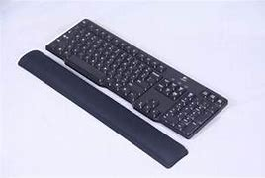Use equipment such as wrist wrests to stop your wrist being bent in an unhealthy position.

### Risk when producing an interactive media product

If a developer was using developing for many hours a day, and therefor typing and clicking constantly, then that could pose the risk of RSI.

## Eye stain/Headaches

There is quite a high chance that if you use a computer frequently you will have some form of eye strain no matter how healthy your eyes are. Eye strain comes as a result of staring at a computer for a long time frequently and can come in the form of:

### Symptoms

* Dry eyes
* Blurred vision
* Eye twitching
* Pain in your neck and shoulders

### Prevention

Eye strain can often lead to headaches. However, using a pair of blue light blocking glasses like these can help prevent both

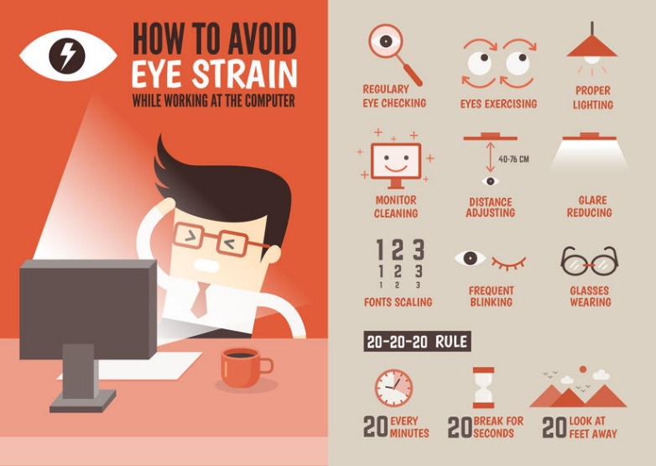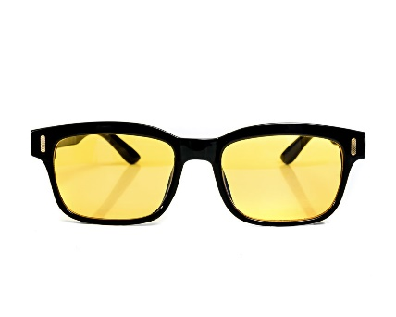

Risk when producing an interactive media product

Staring at a screen constantly for hours while developing your interactive media product while being too close to the screen or with the screen on too bright could quickly result in eye strain and/or headaches. Taking a break and looking away from screens for 5 minutes every now and again would help greatly.

## Upper/Lower Back pain

Poor posture can cause back pain when using your computer for an extended period of time. This can be because your chair is too high/too low, your monitor is at the wrong height, you’re slouching or bent over, etc

[Art of sitting | Posture](https://www.posturite.co.uk/help-advice/useful-resources/learning-guides/art-of-sitting)

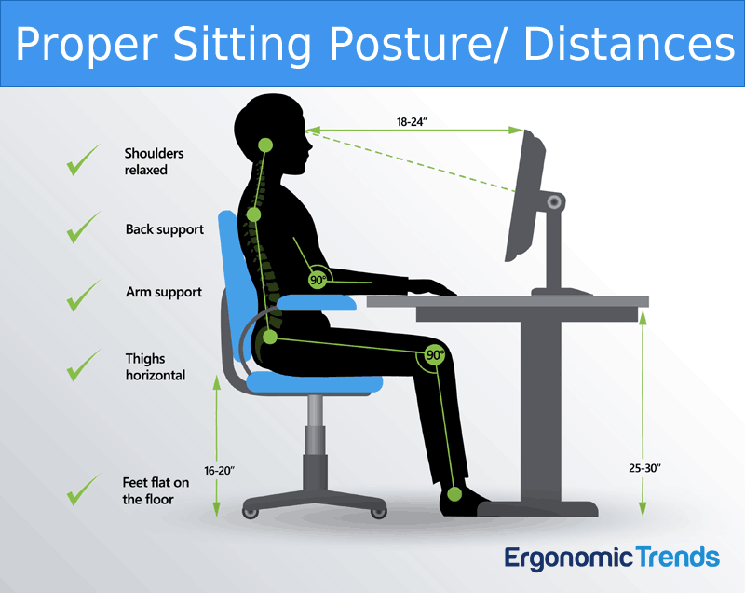

### Symptoms:

* A dull aching pain that is present in the low back.
* Pain that can travel to the legs and even the feet.
* Pain that increases after sitting for an extended period of time.
* Tenderness when you touch the painful area.
* Stiffness.
* Tightness.

### Prevention

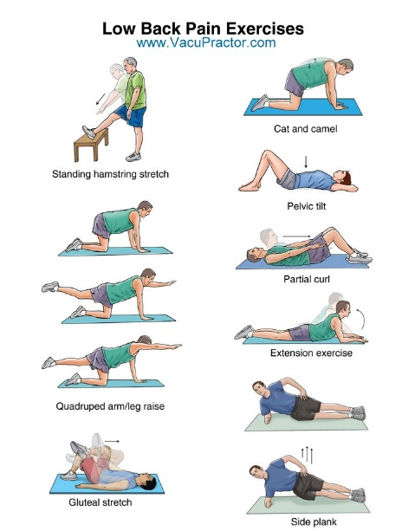

^ These are examples of some streches that can help back pain.

### Risk when producing an interactive media product

Sitting with the keyboard, mouse, or screen at a bad position in relation to your body, meaning that your hands, back or neck would be stained for an extended period of time while developing your product could cause temporary or lasting upper or lower back pain.

## Leg/Foot strain

Although it may not seem obvious leg and foot strain can be quite common when sitting on a chair in the same position, especially if your legs are crossed.

At the end of the day raising your legs above your heart can decrease swelling. Walking around every half an hour or so and shaking your legs can stop leg pain before it even arises.

A poor chair can cause foot strain because your foot will not be flat on the ground, again getting up and walking around will help and so will rotating your ankles.

### Symptoms

* Pain when walking
* Swelling
* Limping
* Bruising around the foot/ankle
* A decease in muscle strength

### Prevention

A sitting standing desk can help because it makes adjusting your posture easier and so you don’t have to move all your belongings and standing while working can greatly help your legs and feet.

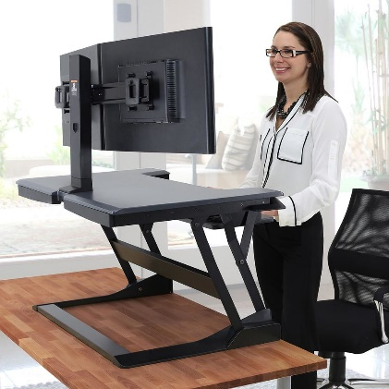

### Risk when producing an interactive media product

Sitting in a bad position can be detrimental over time, but sitting, even in a good position can still cause problems and standing up and walking around periodically (for instance as once every 30 minutes) or investing in a sitting standing desk would be ideal.

# Target audience

Disclaimer:

This information is generalised and by no mean applies to everyone.

## Gender

Gender was commonly used to market products but is being gradually phased out through time. One way was to use colour, for instance colours like red, pink, and purple were commonly used for women. And colours such as grey, black, white (darker colours) were used for men. For children of the same gender the same colours are generally used, however they are more exaggerated. Certain themes such as princesses and ponies and bright sparkles with the same colours were also used for young girls.

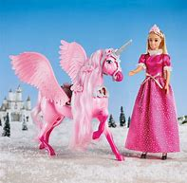

And themes relating to combat and adventure were used for young boys, this was incredibly sexist and is now being challenged.



## Age

Age can be a large factor when designing a product. For instance, when a product is being designed for young children then there are more likely to be brighter and more colourful elements. Especially with games.

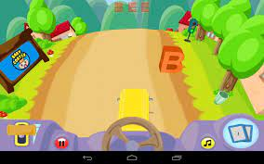

Whereas, if a product is being designed for adults there will be more complex settings and more professional uniform colours.

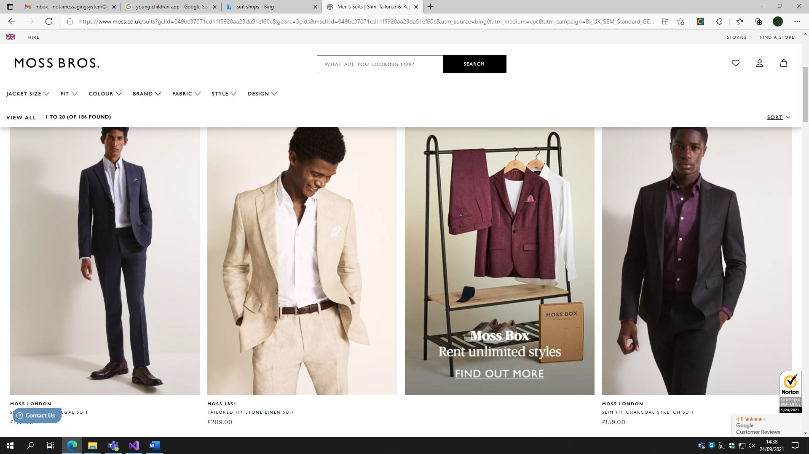

[Men’s Suits | Next UK](https://www3.next.co.uk/shop/gender-men-productaffiliation-suits-0)

If a product is being designed for teenagers it will likely be somewhere inbetween the kind of design for children and adults, colours less exaggerated but also no where near as uniform as for adults.

When the designs are creating the product, they need to be careful not to use complex language when they are designing a product for children because the children will be unlikely to use the product as it could be quite overwhelming and hard to understand. Likewise, when designing a product for adults they need to make sure it’s not too basic as the product could be infuriating to use.

## Income

Products can be targeted towards people based on how much money they earn, for instance a streaming subscription that costs £10 a month is unlikely to be marketed towards people on low/medium income as they can’t afford to spend that much money.

https://www.netflix.com/gb



Following this trend apps and games which are free are targeted towards everyone no matter what their income because people on low/medium income will be unlikely to purchase games with a £40 plus price tag. However, games with in-app purchases or some form of optional premium subscription will be more appealing to them and therefor probably marketed towards them.

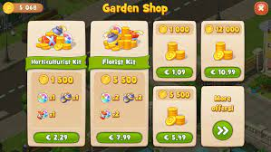

## Location

Depending on where people live, for instance their country will influence what products get recommended to them. For instance, a French speaking person living in Paris won’t get recommended a product which only has German as a language option.

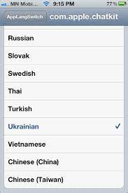

Some products such as google maps apply to nearly everyone no matter where you are in the world (with some small restrictions) as it gives directs and is a global app.

[Google Maps](https://www.google.co.uk/maps)

In some countries there is heavily restricted content which will of course change what you do online as some things will be just downright illegal.



## Lifestyle

Lifestyle can refer to people’s hobbies, how much time they spend outside or what they do for a living. For instance, people who go out on cycle rides/runs often will have products recommended to them that can record their route and speed.

https://www.strava.com

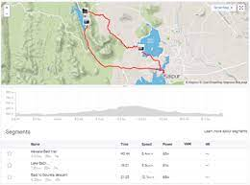

Or if you enjoy gaming then you are more likely to visit websites giving information about a certain game. If you enjoy Tennis and gaming, then you would be even more likely to enjoy a product like Wii tennis.

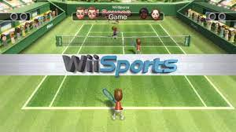

## Accessibility

This can refer to people who might have certain conditions which affect their online experience. For instance, if someone is slightly colour blind then you might add coloured overlay to improve their experience or if someone is deaf then you could add subtitles.

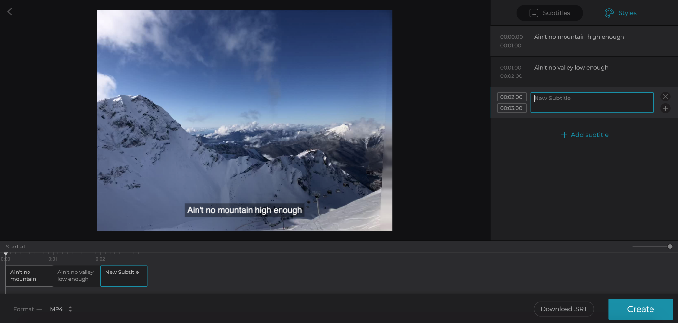

If your eyesight is poor, then a form of text to speech could be very helpful or some kind of larger font or zoom feature would be very beneficial.

[Text-to-Speech | Vonage](https://www.vonage.co.uk/communications-apis/campaigns/tts/?utm_source=Bing&utm_medium=cpc&utm_campaign=ukin-api-core-nb-voice-tts-en-b-e&CMP=ONB-API-UKIN-VOICE-MSFT-EM-DCTEXT-1111118026&utm_term=speech-text&utm_content=_&device=c&matchtype=e&adtest=&kwid=p55860971002&gclid=408fc6f01d1d1406eca6a7a70b5e6035&gclsrc=3p.ds&msclkid=408fc6f01d1d1406eca6a7a70b5e6035)

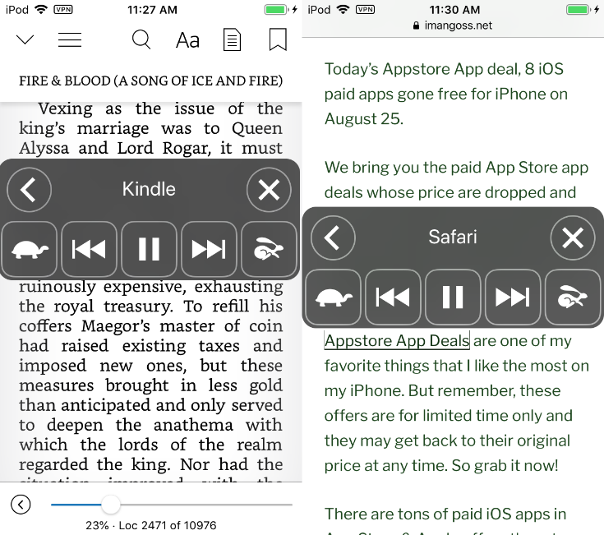

## Game case study

Minecraft

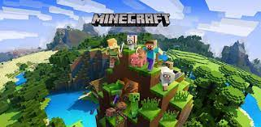

* Gender – Gender nothing marketed towards a specific gender.
* Age – 5+ due to very mild forms of violence involving swords.
* Lifestyle – If you like gaming and/or creative things then you’re probably going to like Minecraft.
* Accessibility – Unless you are completely blind you will probably be ok as it comes with subtitles, and ways to increase the size of text.
* Income – low to medium income because it costs roughly £20 and then you have it forever and never need a repeat payment.
* Location – Anywhere because it supports and range of languages and is not set in any specific real-life location.

Minecraft incudes public servers and single player worlds. Which are helpful as younger children can be restricted to single player worlds because parents might not want them to be exposed to things other players might say on multi-player servers.

## Website case study

Met office

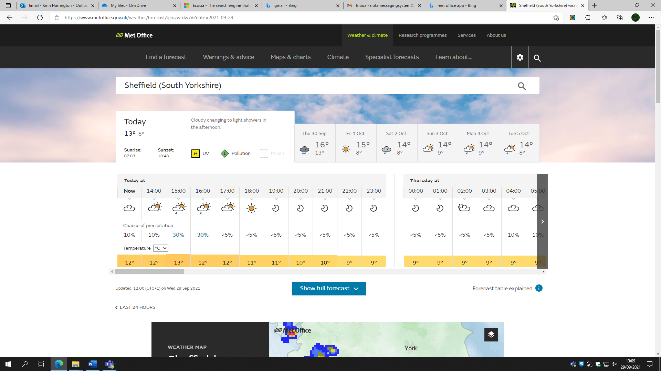

* Gender – Nothing to suggest it is marketed towards a specific gender.
* Age – 13+ likely to be too complicated for younger children.
* Lifestyle – If you play a sport or enjoy an outside hobby then knowing the weather can be extremely useful.
* Accessibility – The website has a whole page dedicated to accessibility including being able to zoom up to 400%, being deaf is not an issue as the website needs to audio. However, there are no coloured overlays.
* Income – Pc’s and phones are cheap, and the website is free and easy to access so anyone can use it.
* Location – Has locations all over the world so location is not an issue.

The Met Office website includes accessibility settings such as the option to zoom in and a black on white colour scheme that is easier to read. Whereas, other websites such as [Weather (msn.com)](https://www.msn.com/en-gb/weather/today/weather-today/we-city?el=6tDcVfrLkmnRB%2BUmo%2BVpR4egA56Qx%2Fdt9PWbQ9aAP06ea0wTmdzQSWw9gHgPDqnt&ocid=ansmsnweather) has no zoom support and a white on blue colour scheme which is significantly harder to read for people with problems with their eyesight.

## App case study

Discord

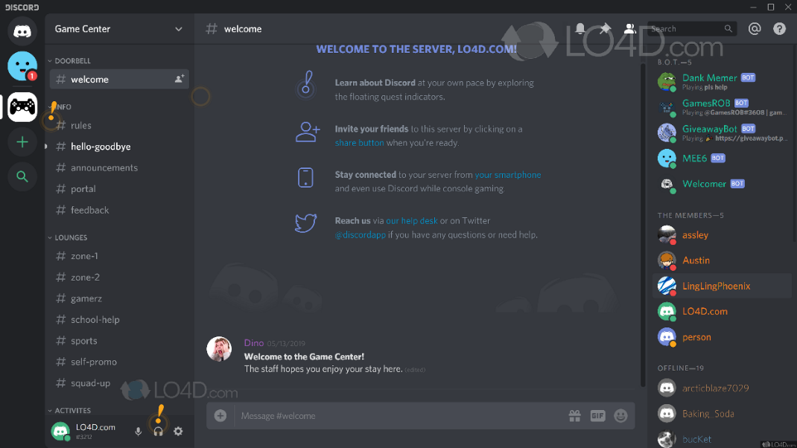

* Gender – No evidence of a specific gender for it to be marketed towards.
* Age - As it is a public messaging app it could have potential risks for under 14’s.
* Lifestyle – It is marketed towards gamers because they market it as the top messaging app for gamers.
* Accessibility – You can customize the size of text to help with eyesight but contains no coloured overlays.
* Income – Completely free so any income bracket. Although it does contain a paid for subscription to gain addition features.
* Location – Unless it is banned in your region then it is marketed towards every country.

The features of this app include direct messaging and group servers, this could be because some younger users could have some safeguarding issues if they joined servers with people that they do not know there for direct messages with people they know in real life would be safer. Discord contains privacy controls & safety controls that stop people messaging you before you have accepted them as a “friend”, and it can also scan and delete messages with explicit content.

# Features

## WhatsApp

WhatsApp is a popular messaging app where you can communicate with friends and colleagues in either a group or direct messaging.

* Send message: You can send a text message by typing in the text box then clicking send which can either be sent to a group or individual person.
* Change personal info: There is a small area where you can input information about you for others to see.
* Call someone: You can press a button which will call someone in your contacts and have a conversation over the phone which can be switched to a video call so you can see each other at the same time
* Send Image: If you have an image on your phone then you can attach it to a message by clicking the paper clip symbol then selecting the image, you can send text in addition to this.
* Receive video: Someone else in your contacts can send you a video which you can click on to watch the video.

### Target audience

This would be targeted towards people who are older than 14 due to internet safety and exploitation issues and it also requires a smartphone to use which younger children won’t have. It is free to use and has no geographical restrictions, so it is accessible to everyone.

## YouTube

YouTube is a video streaming platform where content creators can upload their videos for their audiences to watch with multiple other features.

* Press like button: Click a button which appears as a thumbs-up which increases the videos popularity and increases the number of likes.
* Subscribe: Increases the content creators subscriber count which can be a relatively accurate measure of their popularity, content creators with high subscriber counts videos are more likely to be on a user’s for-you page. There is also a separate channel where you can see what videos the people you have subscribed to have uploaded.
* Watch video: You can click on a video to watch whatever the creator uploaded. You can find videos through your for-you page, through your subscription channel where you can see all your subscriber’s videos or through the next bullet point.
* Search for video: There is a search bar where you can search for the title of a video and can filter by time added and other filters, Videos are ordered by most popular to least popular.
* Report video: You can report a video using a pressing the three dots in the top right-hand corner then clicking the flag to report it for a range of issues including sexual content and hate speech.

### Target audience

YouTube is accessible to everyone because they have a kids and adult version, they also have no geographical restrictions and are free to use, apart from a premium version meaning they are useable by everyone no matter their income or location.

## First Bus

First bus is an app in which you can buy tickets, check bus routes, and bus times.

* Buy ticket: You can click the buy ticket button then browse a range of ticket deals, select which is right for you, then chose a quantity to buy, then click buy.
* Find bus routes: Select which bus number and which region and it will show you the bus route on a map
* See bus times: Select which bus stop you are currently at, and it will show you the next busses that are going to arrive.
* Plan bus journey: Select start location, select end location and time to arrive/leave then it will show you multiple possible bus routes for you to choose from.
* Look for travel updates: It can notify you of a road closure or bus cancelation

### Target audience

First Bus app is accessible by people who are over the age of 10, because younger people will not be getting public transport alone and it requires payment details to use, only people in England can use this app as the buses do not run-in other countries meaning there are geographical restrictions

## Subway surfers

Subway surfers is an endless runner game in which your character must avoid various obstacles to keep ahead of the security guard and get the highest score possible

* Play the game, start an endless runner game in which you swipe left, right, up, or down to move left/right, jump, or slide to get over obstacles
* Buy characters, open a shop where you can buy characters and attempt to collect them all, certain characters are also limited edition to encourage people to play the game.
* Buy different boards, open a shop where you can buy different boards which award different abilities to give you advantages in the game.
* Use a daily gift system, keeps you playing by giving you a free reward every day, such as powerups, fragments of characters or boards, which, when you get enough can unlock the character or board, they are part of.

### Target audience

Subway surfers is accessible by everyone who has a phone as it is a free app with a in-app-purchases and no geographical restrictions, it is also accessible to everyone regardless of income, gender, and age

## Beat saber

Beat saber is a fun rhythm game where you slash notes to the beat of a rhythm with the sabers in your hand.

* Select a song - scroll through a large number of songs to pick which one you want to play and what difficulty you want to play it on.
* Choose what modifies you want to play with - they can make your game harder or easier depending on the modifier, such as giving you extra lives, or making the song faster
* Chose different modes - such as 90-degree, 360 degree or single saber
* Try and beat high scores from other beat saber players.

### Target audience

Beat saber is only accessible by people who have a virtual reality headset, which are quite expensive, and the game also requires you to buy it, because of this it isn’t accessible to people with low income. Younger children may not be able to use it because the headset may not fit on their head.

# Creative processes

## Storyboards

A series of images or drawings, that usually contain some form of instructions or directions, representing stages in development of a project or scenes in a TV show or movie.

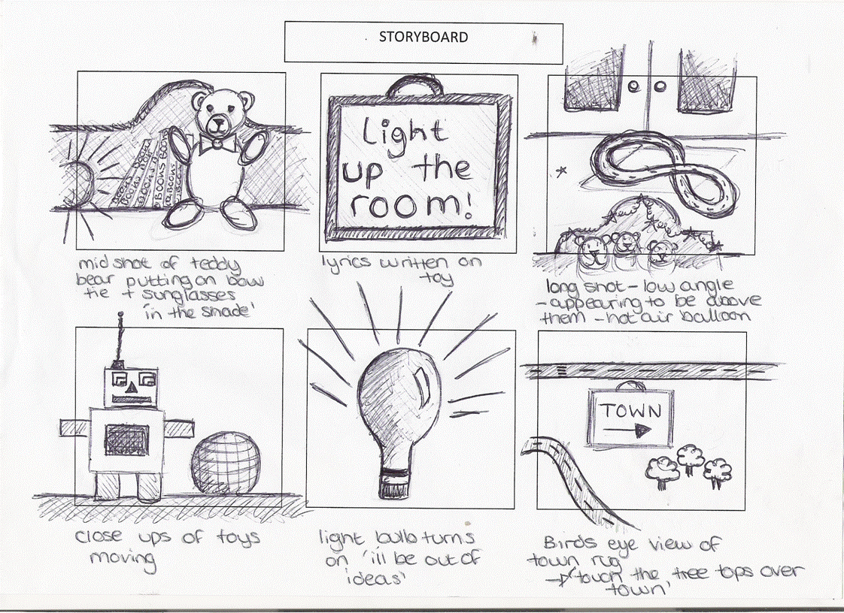

## Mood-boards

A collection of images arranged on a canvas with the purpose to show a style or project concept. This could be made in either a casual or structured style.

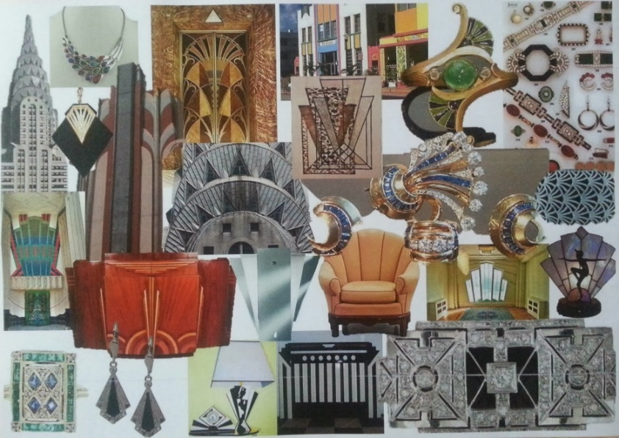

Brief: An outward bounds company is planning to develop a new set of adverts which convey a theme of “adventure”

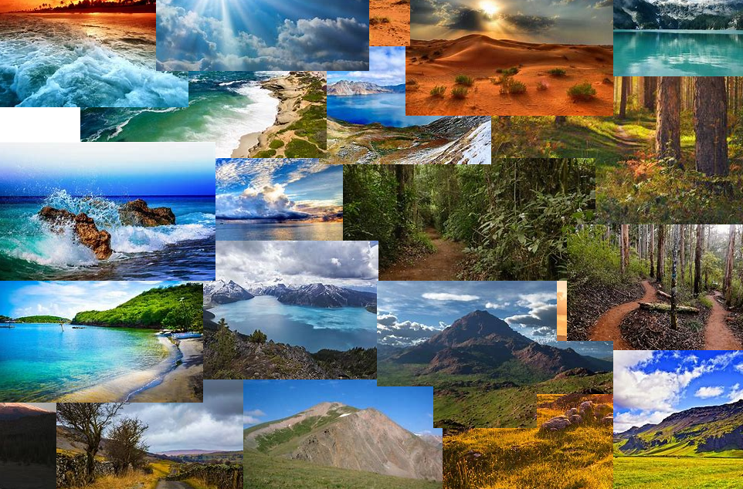

Brief: A new interior design company is considering a new range of bedroom furniture for girls with a theme for “racing”.

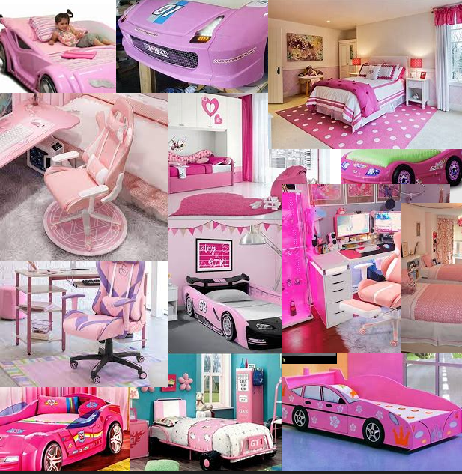

Brief: A local nursery is planning a new poster to advertise the business with the theme of “fun and learning”. 

### Extension: Linking with previous sections, Computer related Health and Safety

This is a mood-board describing products that can be used to help medical conditions caused by computer use. For instance, blue light protecting glasses and standing desks.

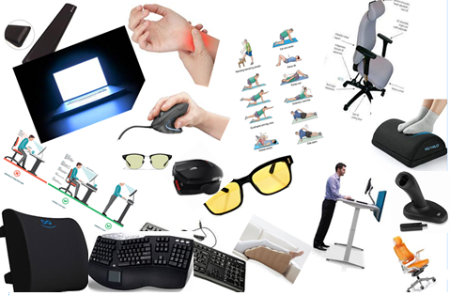

## Scripts

Written text of a performance, for instance a movie or play. It can be written for a specific character or to involve every character.

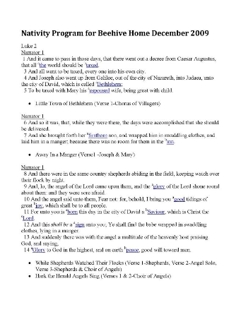

# Sources of information

## Types of sources

### Primary source

The original source, where the data originated.

For example

* Poems
* Court record
* Diaries

### Secondary source

A secondary source interprets, adds, or analyses a primary source

For example

* Wikipedia
* Newspapers (often not all)

### Tertiary source

They collate a list of primary and secondary sources

* Indexes
* Databases
* Abstracts

### Data vs Information

Information is just data which has been interpreted and/or processed.

### Primary, Secondary or Tertiary?

“When looking for a collection of other sources”

* Tertiary, because it is simply just a list of other sources, both primary and secondary.

“When looking for someone’s analysis of data”

* Secondary, because someone has taken some original information and edited and added to it.

“When looking for the original data so you can analyse it yourself”

* Primary, because it is data coming from the original source.

## Sources for projects

### Internet

A global network where you can access information freely, you access this via a virtual device.

### Books

A written piece of work with the purpose to entertain or inform which you usually have to buy.

### Technical manuals

A guide which is specific to the product which is it for informing you on what to do with it, these can be digital or physical.

### Magazines

Provide you with current information of affairs with multiple sections to entertain a wide range of people.

### Newspapers

Inform you with the current information of the day, or top stories from the week, featuring multiple pages with different sections for different pieces of news.

You and your team have decided to build an app, you want red to be the primary colour in the design,

* Who would this appeal to?

People in the country India associate the colour red with purity and would find it calming.

People in the age range 19-24 prefer the colour red to other age groups so targeting the product at this age range would be beneficial.

* List your sources that agree with your audience choice

[How Colour Is Perceived by Different Cultures | Eriksen Translations](https://eriksen.com/marketing/color_culture/)

[Colour Assignment - Preferences (joehallock.com)](http://www.joehallock.com/edu/COM498/preferences.html)

* What explanation did the sources give

In India red has connotations with purity, and brides generally wear red wedding dresses.

Red and blue stay relatively constant with age but they seem to take a slight hike in priority around the age of 19-24

# Techniques

## Websites

One or more pages that the user can cycle through that the user accesses through the internet

Techniques required will vary depending on the content of the website.

Techniques could include

## Website

A combination of multiple pages that a user can access through the web. Some of the techniques that would be required include:

Coding. This would be essential if you are coding the website rather than using a website builder to create the base idea and any features that the website may need.

Image manipulation. This would be useful to resize and design images to fit the website. Design skills to create a theme and to make sure your website feels profession and looks nice.

Colour pallet knowledge. Used to make an active decision on which colours complement each other.

Animation for smooth transitions between pages.

### Example – Wikipedia

Would require coding skills, to not only create the website but to create a system to navigate between pages, HTML knowledge would be required to create the website, add images and videos.

Would require design knowledge to create a professional looking website.

## Game

Coding. To create the game so it is functional and runs without errors. To also make it interesting and complex so it is enjoyable to play.

Video editing. Is used mainly in cutscenes to give context to the game and add to the suspense.

Image manipulation. To create assets for the game, as in characters or items. Also, to create a logo or opening screen. Design. To create a theme to fit the look and feel of the game and make sure colours don’t clash.

Logic paths. to create the logic of events as the game progresses and to plan the route the game should take. Sound editing. to create interactive sounds or music to complement the game and make it more interesting.

### Example – Minecraft

Would require networking knowledge to set up multiplayer and servers.

Coding knowledge would be essential to create the game.

Design elements would require colour and asset creation knowledge to make.

## Interactive presentation

Image manipulation. is required to edit the images for the display, so they fit the screen and add captions or other features.

Video editing. For interactive videos which would add to the presentation and make it easier to follow, especially for younger audiences.

Sound editing. For music or voiceovers to add to the feel and potentially help people who struggle with vision. Animation. for explanation or entertainment to add a better feel for younger viewers who may not be able to follow a more complex presentation.

### Example – Museum presentation

PowerPoint skills to create the presentation

Sound and video editing to add more elements to the presentation

Being able to create interactive buttons to add the interactive element.

## App – fitness tracker

Coding. would be used to create the app and sync data with web servers for leader boards and statistics tracking.

GPS. skills for tracking the user’s location and speed.

Design. to create a user friendly simple and easy to use design which would encourage more people to use the app.

### Example – Strava

Design skills to create a professional feel and improve the apps credibility

Coding to actually make the app and configure it for the phones operating system

GPS skills, how to access the phones’ location and get it to update on an app.

## Linking

### Navigation buttons, links, menus:

* A website

For a website, skills you made need could include. Html to code the website, picture editing to improve the look of your website and add images.

### Hit counters, leader boards, help-sections:

* App, puzzle game

Programming knowledge to make the app,

Web server linking to get high scores and use global high scores

### Game levels, multimedia, power-ups:

* A combat game, which includes different levels and powerups.

## Additional skills

### Literacy skills

Literacy skills will be required for anything which has some form of text or dialogue, having good literacy skills will improve your work significantly and make it seem more professional.

# LO2

# Design basics

## Colour

### Backgrounds

The background colour of an interactive product could be used to invoke an emotional response which the user would then connect with the product. An example of this would be that blue is a colour largely connected with feelings of relaxation and trust and it gives the user a calming feeling.

### Buttons

If a button is important its colour will likely contrast more with the colour of the background to make it stand out and be more obvious, it would also be more likely to be a vibrant colour for the same reasons. A less important button would have more dull colours and would be closer to the colour of the background. A more important button would also be bigger and have a larger font.

### Logos

Memorable logos are important because they make your product recognisable, if you build a good reputation with a specific logo, users are more likely to accept another product if it uses the same logo. Therefor colours are important because they can help your logo stand out and if you connect the colours of your logo to the services you provide then that will create an even stronger feeling of connection in the user.

Logos are also your first impression on a user so a logo with colours that appeals to a user, will immediately make them feel more inclined to use your product.

## Themes/Colour Schemes

The theme of a product is immensely import because it can be the difference between a user staying or leaving. Choosing a colour scheme that looks attractive rather than one that clashes will greatly improve the experience the user will have. It is also ideal if you pick colours that fit your target audience and the services or products you provide.

### Monochromatic

Multiple shades of a given colour but only using that one singular colour and no others. 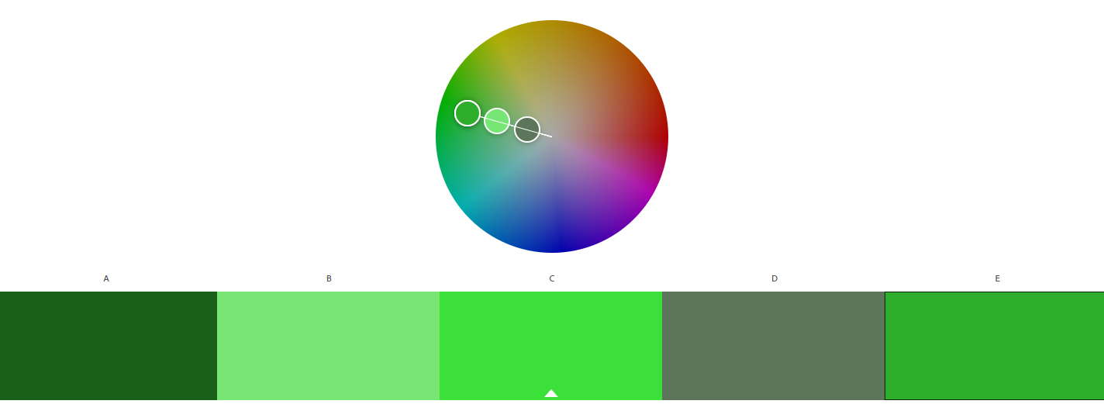

### Analogous

Using three colours that are neighbours on the colour wheel.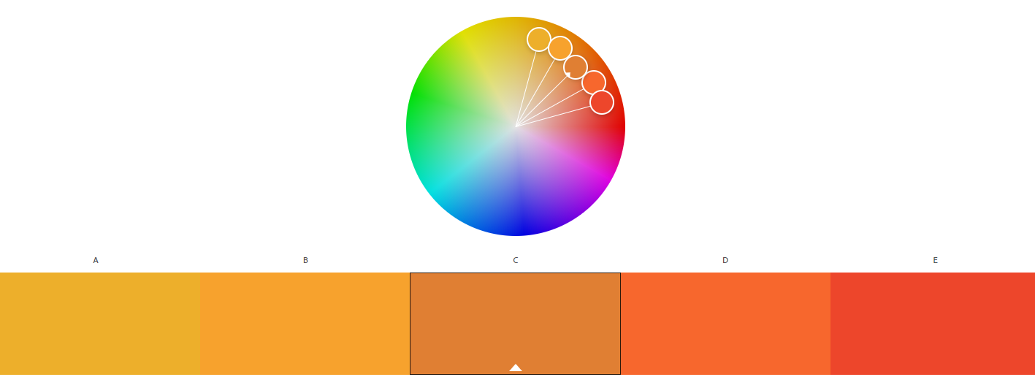

### Complementary

Colours on opposites sides of the colour wheel

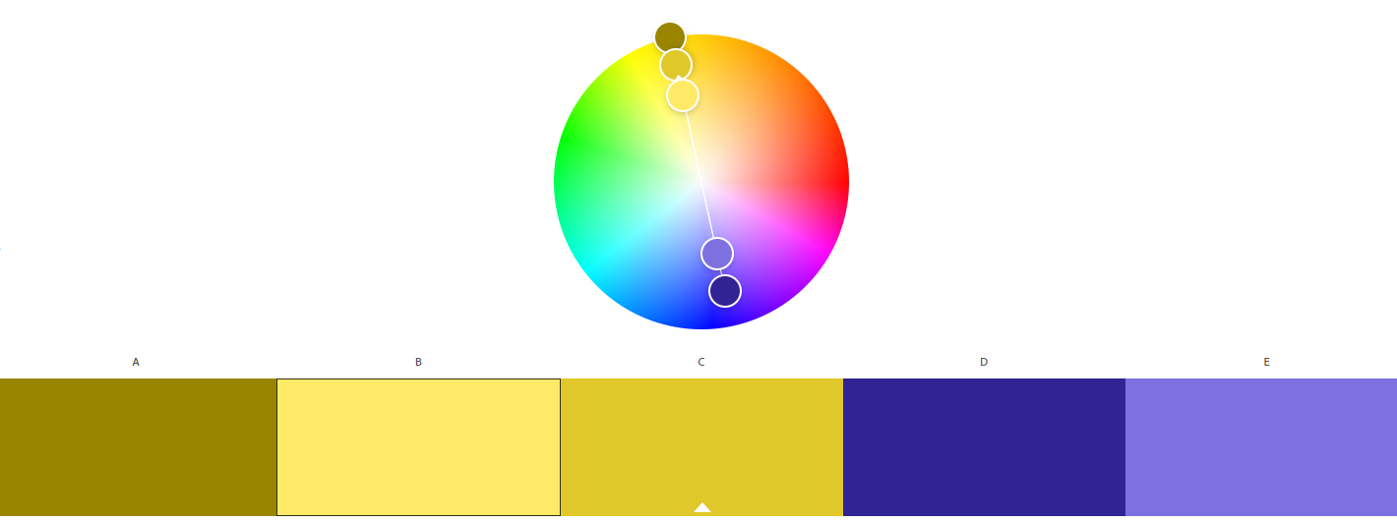

### Split complementary

A group of three colours that is made up of one colour and then the two colours that are on either side of its opposite.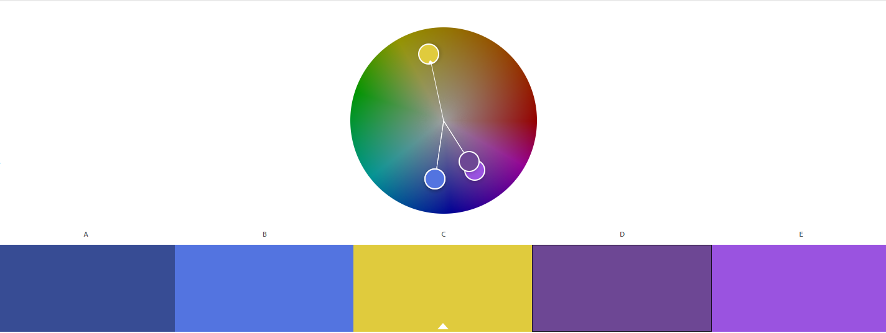

## Picking colours

An app for young children for educational purposes:

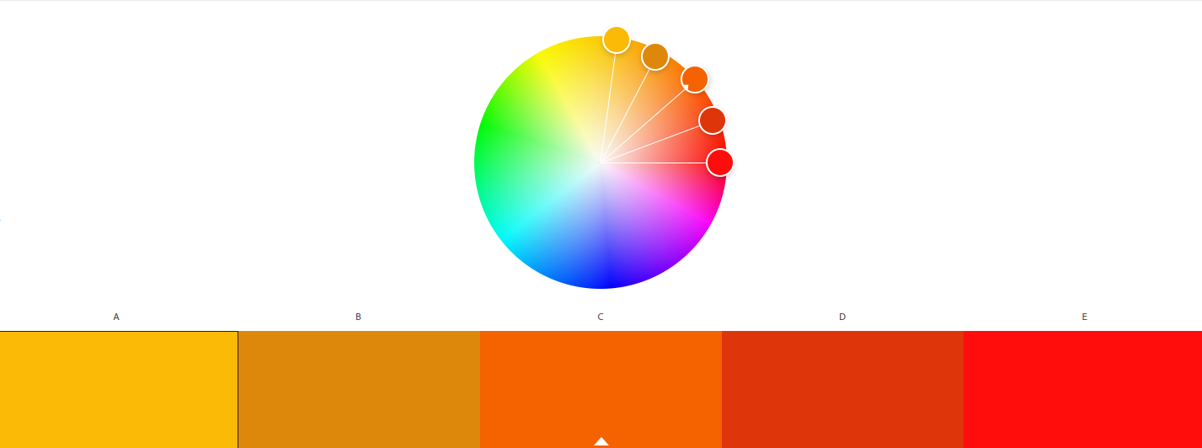

Bright colours appeal more to young children, so this colour scheme will engage them and help them to enjoy the app

An interactive information display at a museum: 

Uniform professional colours to add to the display, not making it vibrant but adding some colour so it isn’t boring.

### An interactive informational display for people with poor eyesight.

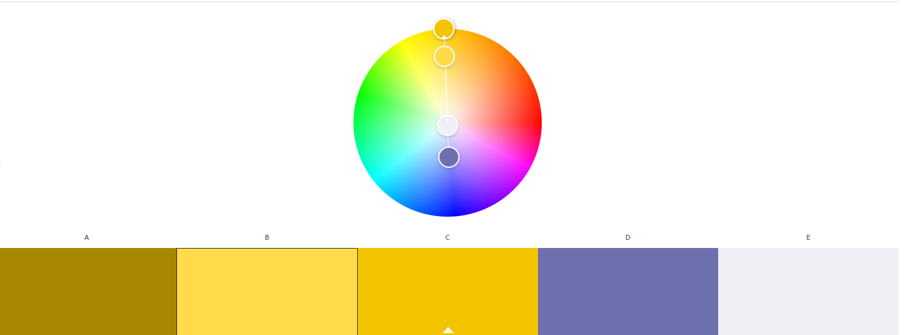

High contrast including yellow and white to make the text easier to see, making the app better for people with eyesight problems.

## Fonts and typefaces

### Sans vs Sans Serif

Sans Serifs are more uniform fonts which generally don’t have any extra embellishments to add to the decorated look (shown on the right)

Sans fonts are more used for fancy decorations and eye-catching displays rather than fonts used more generally, as a result of this they have extra parts to add to the look, they can be said to mimic handwriting more (shown below)



## Whitespace

A section of a document that is unused, or empty space around an object, white space helps break up a document and draws attention to important areas, it helps the document look less crowded and less daunting to read and helps the reader find what they are looking for quicker.

### Good uses of white space:

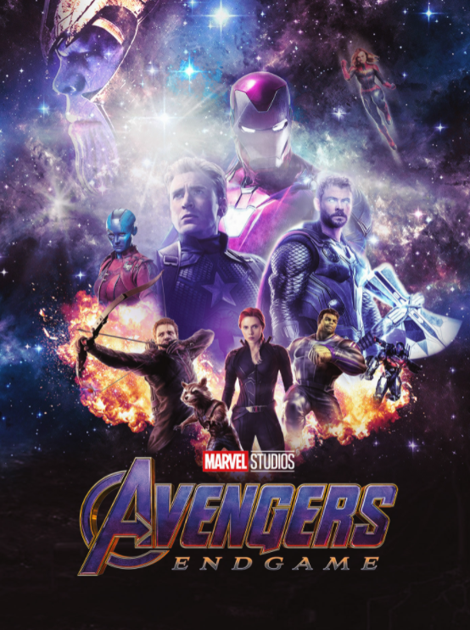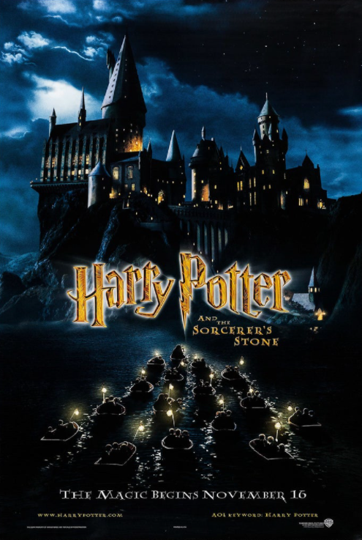

### Bad uses of white space:

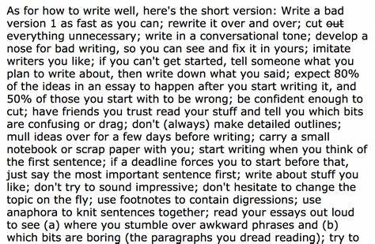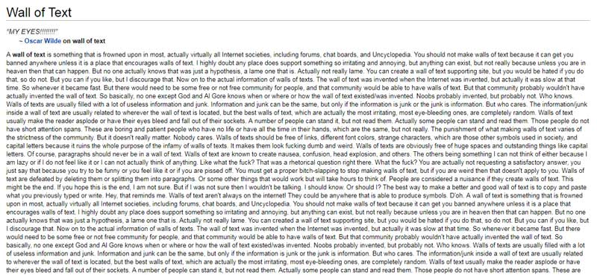

## House Style

A house style is a company’s branding which makes them recognisable and gives the user trust in them. This is created using unique colours, text, fonts, and layout, for instance:

**NOTES: include screenshot of website, use of whitespace, colour, etc**

You are on a team developing a website for a newly built school. There should be elements of the colour orange used as this is part of the logo. But the other colours are allowed too.

### Colours

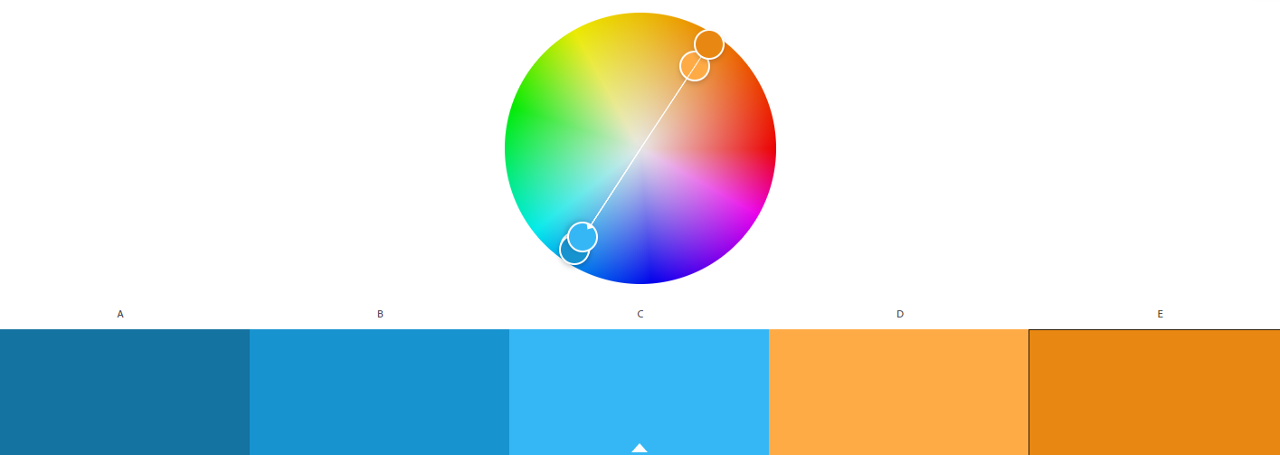

I choose analogous colours to complement each other and add a profession feel.

* What fonts would be used?

Entirely sans serif, I think Consolas would work well, to improve readability and because no fancy designs are required.

* Amount of white space?

A decent amount so that the website does not seem intimidating and to highlight key information.

* Explain all of your decisions

I think the combination of the colours blue and orange with the contrasts well with the white space highlighting the information and the sans serif font making it easy to read and helps it not look to busy.

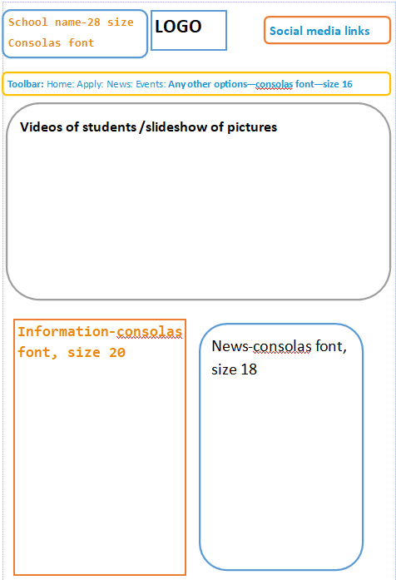

# Editing images

### G.I.M.P

G.I.M.P is a free and open source (meaning that anyone can edit the source code and distribute their changed) this piece of software means that anyone can download and use image editing software. It aims to imitate photoshop and provide the same services for free, it works on many operating systems such as Windows, Linux and MacOS.

### Paint.Net

Paint.Net is similar to G.I.M.P as it is also free and open source, however it only supports windows, so Linux and MacOS users cannot use it. It features a variety of useful of tools, layer support and unlimited undo’s, plugins can also be added to enhance the experience. It provides people with an advanced service allowing for professional results.

### Adobe Photoshop

Adobe Photoshop is a premium image editing software costing £177.45 per year meaning that while the other pieces of software are free, people have to pay for photoshop, and it isn’t open source meaning that people cannot edit the source code, or even access it. However, it is extremely high quality and the most widely used by industry and recognised as the most advanced and best quality software to use.

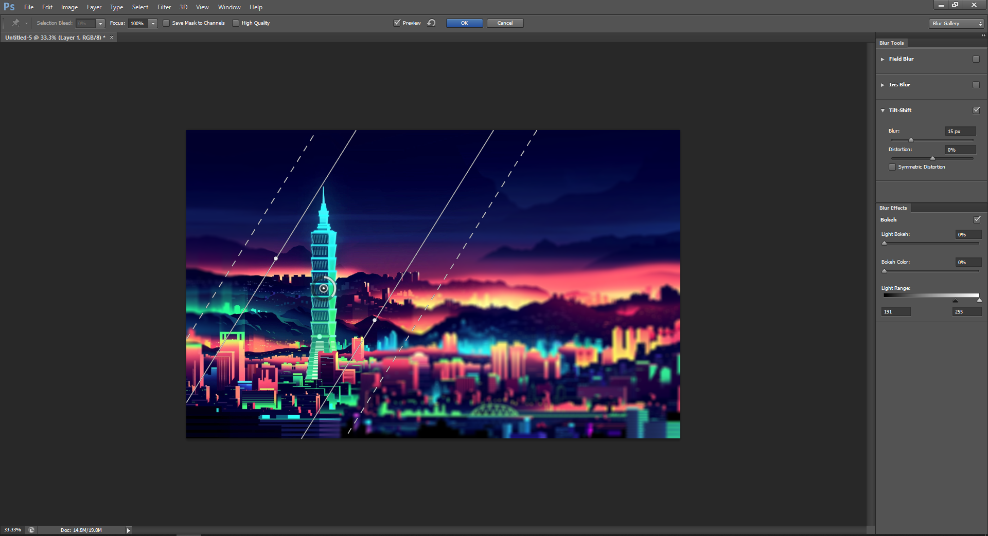

### Instagram

Instagram is social media rather than a dedicated image editor, it does still contain an image editor for the purpose of editing images before you post them, it is still free but isn’t open source, not the most advanced option but it is a mobile app and is better than nothing

|  |  |
| --- | --- |
| See the source image | This is the original picture. |
|  | I opened the blending options and added a purple colour hue. |
|  | I added another image and used the transform tool to make it the right size. |
|  | I decreased the opacity to 40%. |
|  | I added the tilt-shift tool and moved/rotated it. |
| Modern thin laptop isometric icon Royalty Free Vector Image | I added a new image which had a white background. |
|  | I used the quick selection tool to remove the background. |
|  | I added text and changed the font. |
|  | This is the final image. |

|  |  |
| --- | --- |
|  | This was my original image. |
|  | Before/After using the heal tool to remove name on the boat. |
|  | I used the colour overlay – hue tool to add a warm red hue to this image. |
|  | I used the tilt-shift tool to blur the image and focus the boat |
|  | This is the final image. |

## Website authoring

### Notepad

Notepad is a free piece of software that is automatically installed on any windows device, it allows for text editing and can be used to edit websites, however it lacks features that most IDEs give such as syntax help and error finding.

### Brackets

Brackets is a free piece of software available to be downloaded on any operating system, it has a lot of features such as line numbering and syntax corrections, it is very helpful and can be used to edit websites.

A local bookstore called “Sheffield’s local bookstore” would like to set up a website where users can view information about their store. They would have no logo or actual content to use in the site just yet, however they would like you to produce an outline for the website.

|  |  |
| --- | --- |
|  | Added the title for the bookstore. |
|  | Changed the colour of the text to black. |
|  | Added a background image which fits the brief of the bookstore. |
|  | Added links which connect to the bookstore’s partners. |
|  | Added a list where popular books for people to try could be advertised |
|  | Added an area where they can write a description for their website |
|  | Added a bar where links to other pages can go. |
|  | Added images and paragraphs. |

Brackets

I used brackets for my website authoring.

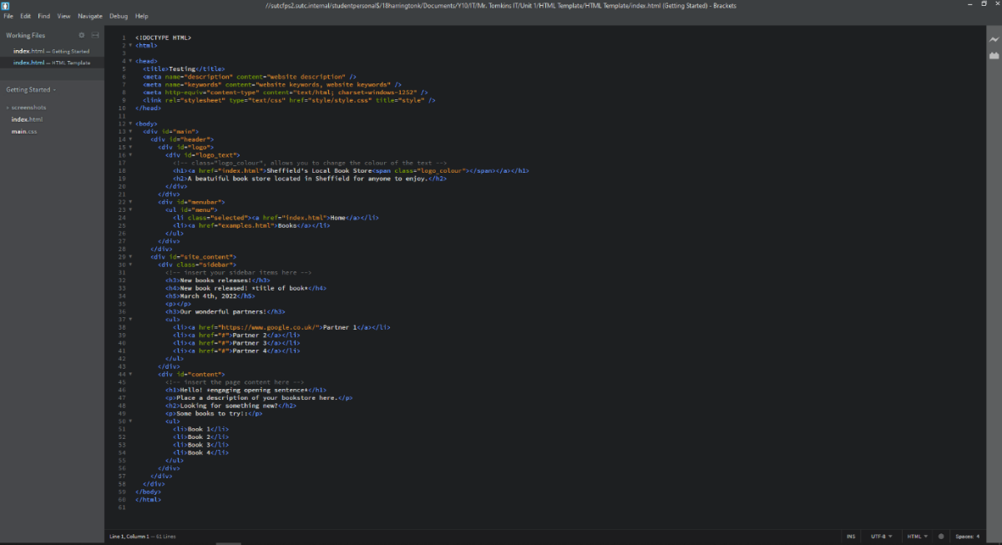It is an IDE used for multiple programming languages, it is recognised as a professional programming language

Edge

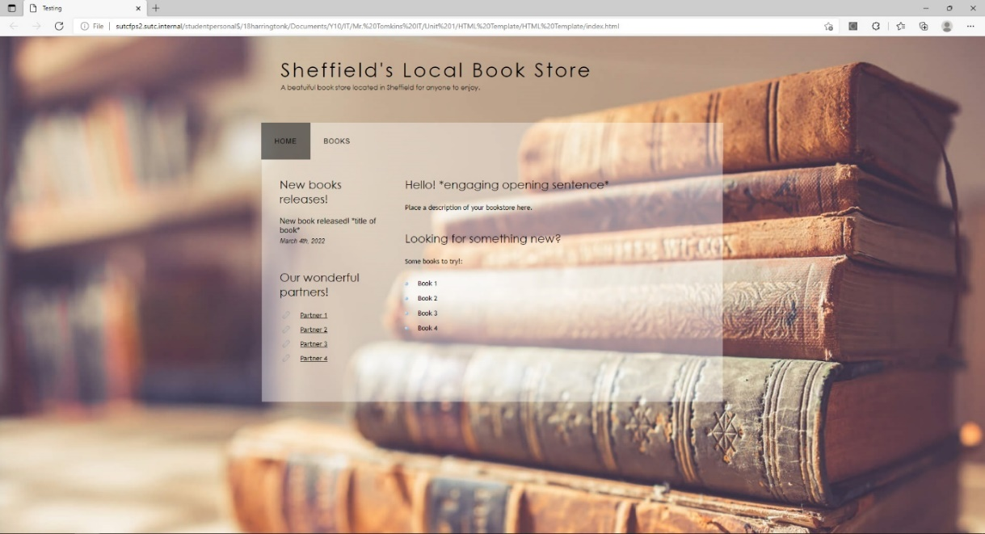Edge is a free web browser which can be used to access everything on the internet and provides a range of options, in this scenario I have used it to view my brackets project.

## 3D modelling

A new website called Modelly will be used to share and sell 3d models for use in animations and games. In order to get started, they require a small catalogue of 3D models that they can use on their website.

Blender

Blender is a tool for 3D model editing which provides a wide range of tools and options to create and render professional models.

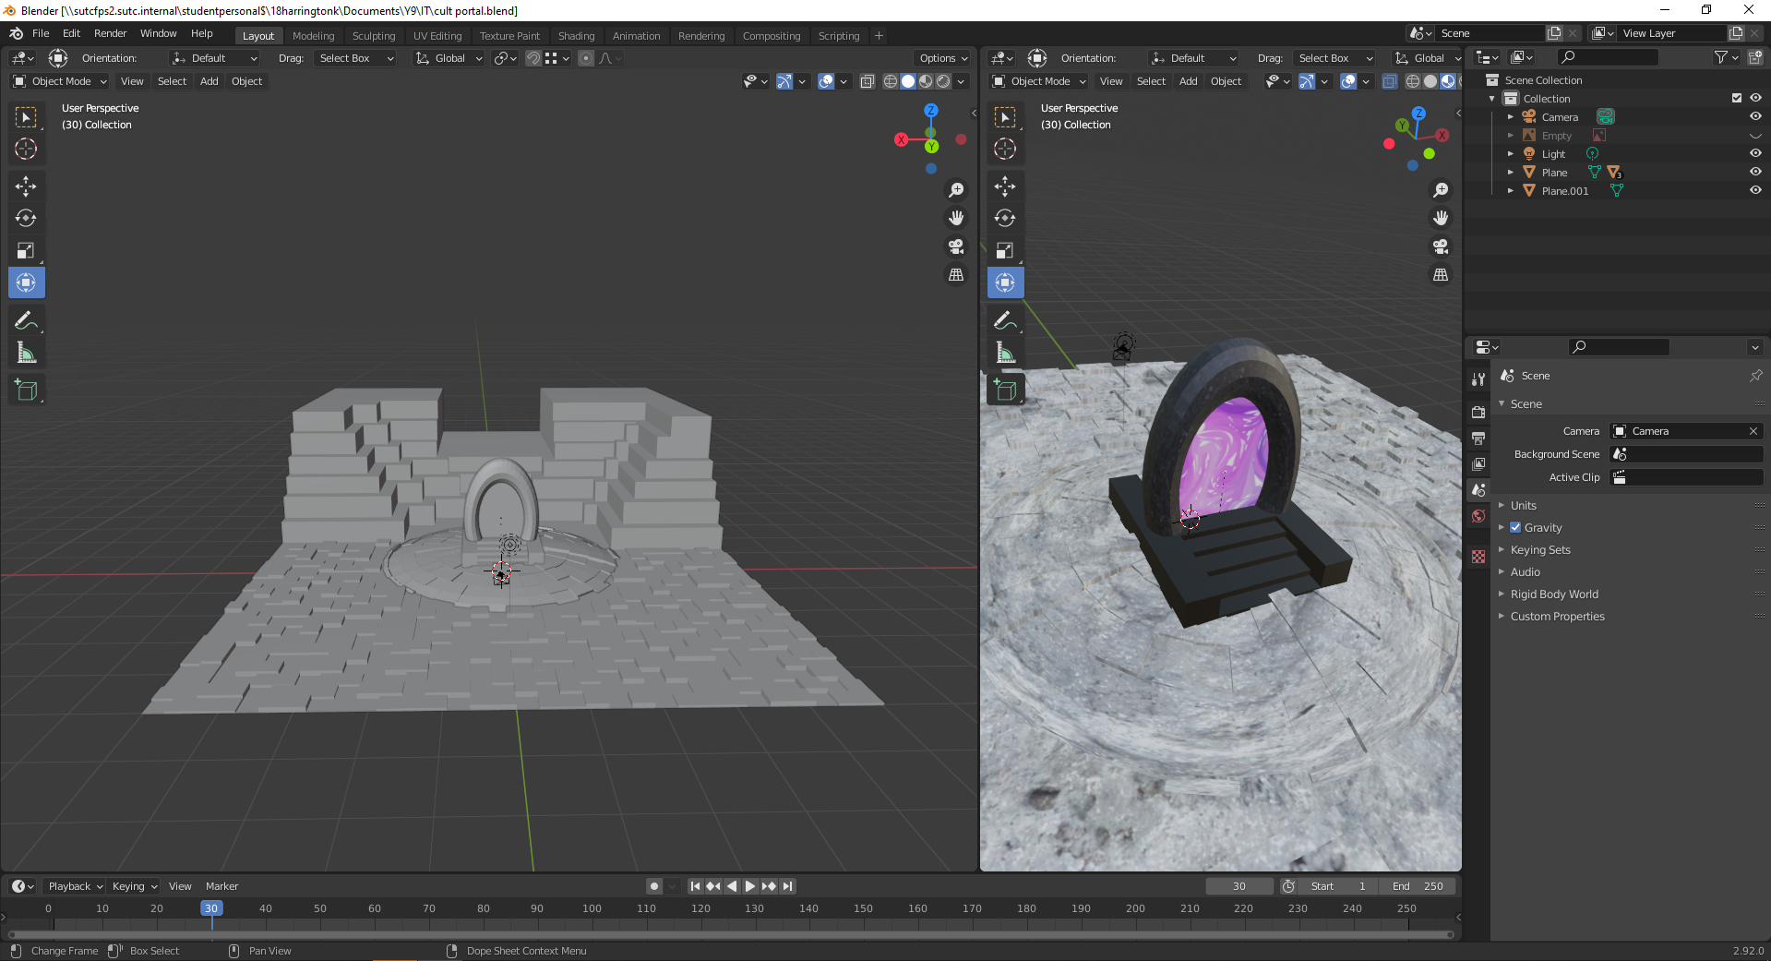

|  |  |
| --- | --- |
|  | I merged cylinders to create the main body, and extruded and rotated cylinders to create the fuse. |
|  | I modelled a plain to create the floor and added a tile able image. I created a rock face and subdivided and extruded parts of it to create a somewhat realistic rock face. |
|  | Here is a close-up image of my subdivided and modelled plain. |
|  | I created, rotated, and extruded a plain, then added an image texture to simulate the sky. |
|  | Added plane, added an image texture, extruded parts then duplicated them to create a four-sided building. |
|  | Added a plain, resized it to the correct size, and then arranged the buildings on it. |
|  | Added and edited many shapes to create a natural looking floor and a pedestal for a portal to sit on. |
|  | Added a plain, attached some of the vertices to a pole, then added cloth physics to the plain, and created a wind source to blow it. |
|  | I added multiple cubes and extruded them, added free body modifiers to test a ball rolling. |

# Interactive presentation

A local company that buys, restores, and sells furniture would like a presentation to advertise their services. The company is called Resture and is based in Parson Cross, Sheffield. They buy mostly wooden furniture, restore, and repair it, and then sell them on.

The presentation needs to show off their services as well as their prices

|  |  |
| --- | --- |
|  | I choose this presentation because it follows the theme of the company, as they restore and buy mostly wooden furniture. It is also eye catching and will grab a customer’s attention. |
|  | I used a short title to immediately grab the user’s attention followed by a short amount of information. |
|  | A small amount of info describing briefly one of our services with a background that fits the theme. |
|  | A wooden background continuing with the theme to link to the companies’ services along with information about their restoring services. |
|  | The same as the previous slides, a fitting background and short, to the point title to grad their attention. |
|  | A table detailing the prices in a simple, easy to understand and eye pleasing way. |
|  | I added a “wipe” transition between slides to make it look more professional and appealing to the eye. |
|  | I added animations to add interest to the PowerPoint which would make it more interesting to use. |
|  | I turned on “loop continuously until “Esc”” so the PowerPoint will continuously cycle until the exit it. |
|  | I added action buttons which hyperlink to the next/previous slide. |

PowerPoint

Power point is used to create professional presentations with an immense number of tools allowing for an engaging and interactive product.

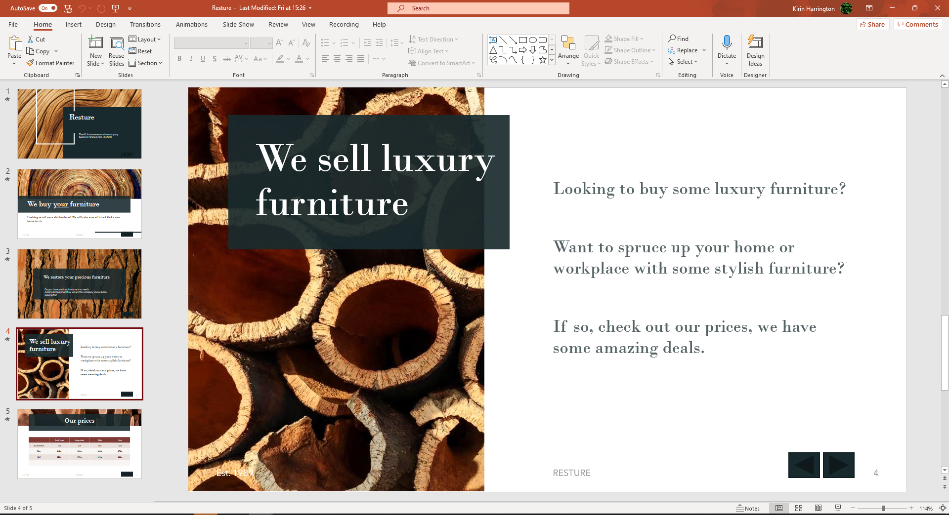

# Hardware experimentation

## School PC

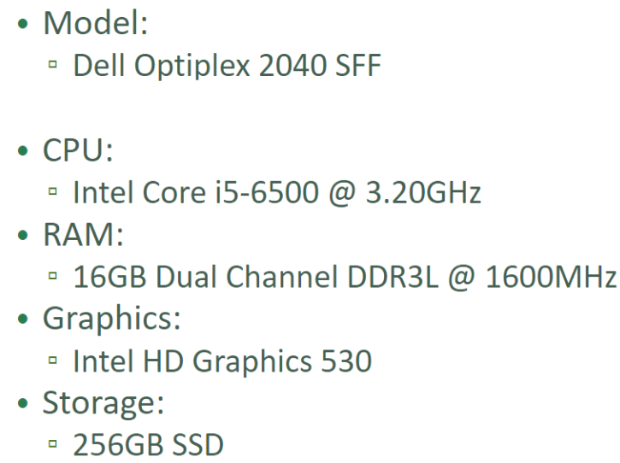

I used the school computers because they were readily available and consistent, meaning I knew what software they would have and how fast they would run, there were also an abundance of them meaning there was always a machine available. However, they are not the most up-to-date machines so don’t run the fastest, the school has also installed software on them that isn’t required for this qualification which will have taken up storage space unnecessarily and slowed them down.

## Phone hardware

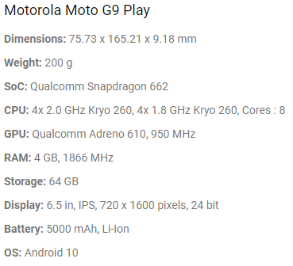Moto G9 Play, I used this phone for research and for collecting assets. As we carry our phones around everywhere they are very convenient for research on the go and have a large amount of functionality, however, some software isn’t available on your phone and the screen is smaller, so text is harder to read.

## Peripherals

Peripherals I used were:

### Mouse

An external piece of hardware which lets you move the cursor and click.

Keyboard

* Monitor
* Speakers/headphones

I used a keyboard to type out my portfolio as well as do research for the course, without a keyboard making a portfolio would’ve been very difficult. The monitor has a 1920x1080 pixel display, I used this to view things like my word documents and whatever else I was using at the time. I used my mouse for clicking and navigating through my word document and websites I was using for research, as well as using buttons and loading up different applications. I used my speakers to listen to different tutorials throughout my course to help assist me in my learning.

## Unused hardware

### Macro keys

I didn’t use macro keys because they are too expensive and inaccessible on my budget, these would be useful as I could program specific keys and have my own shortcuts.

### Dual monitors

Dual monitors would’ve been convenient to have as I could’ve had information and research on my second screen and then my portfolio on my other screen.

### A graphics card

A graphics card would have been good for things like blender, as rendering would be quicker and would affect the performance of the rest of the computer less.

### Optimised mouse

An optimised mouse with programmable buttons would’ve helped me a lot when making my portfolio as I could’ve programmed specific shortcuts to assist me in my work, making my experience a lot easier.

### More cores

Having more cores in my Pc would be helpful because then it could run multiple FDE cycles at once, this means that my Pc will run faster overall and gives me more multitasking capabilities.

# LO3

# Image manipulation

|  |  |  |
| --- | --- | --- |
| Technique | Rating (1-10) | Reasoning |
| Colour hue | 8 | I believe I used this tool quite well, I used it to change the lighting in the image to a warmer colour. However, I could have used it better as the colours I chose were too harsh and not realistic enough. |
| Tilt-shift | 9 | I used this tool very effectively to draw focus to specific parts of an image. I could have used it better by being more precise with the separate areas to blur as it was uneven throughout the image. |
| Transform | 10 | I used this tool extremely well as it is quite simple to use, I used it to move and resize images. |
| Opacity | 7 | I used this tool reasonably well, I used it to add a translucent image on top of a background to create a layered effect. I could have used it better by using a keyboard shortcut as it took me a long time to find the correct menu. |
| Quick selection | 7 | I used the quick selection tool to crop out the background of an image, it went well but part of the image was also cropped out. |
| Heal tool | 6 | I used the heal tool to try and erase a sign on the side of a boat, it went reasonably well but the colour of the boat was slightly discoloured. |
| Erase | 9 | I used the erase tool to erase part of my image, it went well however it wasn’t very precise and resulted in a border which wasn’t straight. |

# Website authoring

|  |  |  |
| --- | --- | --- |
| Technique | Rating (1-10) | Reasoning |
| Background | 10 | I changed the background of my website to something that fitted the theme of the website, this went really well and greatly improved the feel of the website. |
| Links | 8 | I used links to reference sources which were linked to my website, and they were very effective, next time I would change the colour of the text to blue, so it was clearer that they were links. |
| Images | 6 | I used images to add visual appeal and to break up large blocks of text, however I had problems with formatting and the images were the wrong size and in the wrong place. |
| Paragraph | 9 | I used the paragraph tool to add large blocks of text, it worked well, but could have been improved by changing how it was centred on the page as it didn’t look very good. |
| Heading 1 | 10 | I used headings to highlight certain pieces of information and separate the page into sections based on the content they contained. |
| Bullet points | 10 | I used bullet points as a way to provide simple and easy to understand pieces of information, this worked very well without any problems. |
| Multiple connected  pages | 10 | I used multiple connected pages so I could have a page for an introduction and then multiple pages for content allowing for there to be more whitespace and making the page easier to read. |

# 3D modelling

|  |  |  |
| --- | --- | --- |
| Technique | Rating (1-10) | Reasoning |
| Move | 8 | I used this tool to move an object along a fixed axis, it was very effective but wasn’t the most precise as small mouse movements could change the location of the object drastically. |
| Scale | 9 | I used this tool very well, I used it to proportionally increase the size of an object and it worked very well for creating a very large object with low amounts of detail then shrinking it to increase the detail. |
| LOOP CUT | 10 | I used the loop cut tool to add extra vertices and edit the object by selecting and moving the objects, it was very precise and worked extremely well. |
| Rotate | 9 | I used the rotate tool to rotate an object along a fixed axis, this was very accurate and could be used for a multitude of things. I could have used it better by using the menu which allows you to rotate by a specific number of degrees. |
| Transform |  | I used the transform tool very often as it combines the scale, move and rotate tools and is therefore a very quick and efficient way to edit objects. |
| Extrude |  | I used the extrude tool to extend sides, edges, or vertices of a shape in a specific direction which was a very useful way to quickly edit shapes, especially when combined with the loop cut tool. |
|  |  |  |

# Interactive presentations

|  |  |  |
| --- | --- | --- |
| Technique | Rating (1-10) | Reasoning |
| Transitions | 10 | I used the transitions very well to create a cleaner transition between slides and to make the PowerPoint look more professional. |
| Template | 8 | I used a premade template in PowerPoint with a wood-based theme to fit my PowerPoint, this went but it contained premade pages which were not required for my project. |
| 3d models | 7 | I used a 3d model to provide a visual representation of my product, this was effective but didn’t fit with the style of the PowerPoint. |
| action buttons | 10 | I used action buttons to allow the user to move forward or back on the PowerPoint, it worked very well and was a useful addition. |
| Automated timings | 5 | I used automated timings to make the PowerPoint change slides without the user having to press anything, this can be convenient, but it can also change slides at inconvenient and unwanted times. |
| Tables | 8 | I used tables to organise data about prices in an easy to understand and visually pleasing layout. |

# Portfolio software

## Microsoft word

I used Microsoft word for my portfolio because it is a well-established, popular, and widely used piece of software which shows how well it works and how secure it is, I also used it because it was installed on the school machines and was suggested by the teacher.

Pros

* It is easy to find help and tutorials due to how popular word is.
* Word is very intuitive and easy to use and therefore doesn’t require any training or special skills to use.
* Has massive potential and gives you the tools to create what you want.

Cons

* It isn’t available on all operating systems.
* Word is made by Microsoft with some people could have an ethical issue with, meaning that they would boycott their services.
* The desktop application of Microsoft word requires you to pay and could be very expensive/not affordable for some people.
* It doesn’t deal with images well and formatting them could be difficult as you have to choose wrap text options every time you import an image.

Notepad

I decided not to use notepad because it has incredibly limited functionality as all you can do is type and it has no options such as changing font size.

PowerPoint

I decided not to use PowerPoint as having my entire portfolio on slides and having to use textboxes for all the text would be incredibly time consuming.

Google docs

Google docs is a very well-established option and a good alternative, however, I decided not to use it as the desktop application of Word was installed on the computers and everyone was heavily encouraged to use it.

Liber office writer

I decided not to use liber office writer as it crashes frequently and is not installed on the computers, it is also having less functionality than word and word was readily available.

Visual Studio Code

I decided not to use visual studio code because even though it does allow you to type, it is not its intended function to write documents as it is meant for programming and therefore is not optimised for writing documents, and it doesn’t have any of the necessary tools.

## PowerPoint

I used PowerPoint to make an interactive presentation as part of my experimentation, it was installed on the school computers, so it was very convenient to use, it is widely used in industry and is so an employable skill, and as such there are a lot of resources which provide information on how to use it.

### Pros

* Very widely used and popular which means that there are lots of helpful tutorials online.
* It contains many helpful tools such as action button which I utilised for my interactive presentation
* Preinstalled on school computers and therefore very convenient to use.

### Cons

* It requires a subscription to use which can be expensive and unaffordable for some people.
* Requires you to use textboxes to add text onto a slide which can be very inconvenient.
* The desktop app of PowerPoint is not available on some operating systems so some people cannot access it.

### Alternatives

I could have used Google slides as it is a very established alternative to PowerPoint and contains a lot of functionality, however, I was used to using PowerPoint, so I found it easier, and it was also installed for on the school computers.

I could also have used LibreOffice Impress but it is less well known and therefore has fewer tutorials so it is harder to learn, it also wasn’t installed on the school computers so would have been less convenient to use.

## Photoshop

I used Adobe Photoshop to edit and make some images as part of my experimentation, it is very popular so there are a lot of online tutorials I can use to assist me, and it was also installed on the school computers.

### Pros

* There is an extensive list of useful tools which I can use to edit images.
* Photoshop has a multitude of keyboard shortcuts which speed up editing and are very convenient.
* There are a lot of tutorials and forums online I can use to assist me.

### Cons

* Photoshop is very expensive, so it’s affordable, and as school paid for it, so I cannot use it at home.
* The file format Photoshop uses is not compatible with any other programs as it exclusively used by Photoshop
* The school computers are not very fast, so it didn’t run very well.

### Alternatives

I could have used Paint 3D, but it contains a lot less tools and cannot create images anywhere near as complex as photoshop can.

I could have used G..I.M.P but I wasn’t familiar with how to use it and it is less well known so there are barely any tutorials on how to use it, it also wasn’t installed on the school machines so it would have been very difficult to use.

## Brackets

I used backets for my website editing experimentation, it is free and has helpful features such as syntax highlighting and other useful tools, however it requires you to know a markup language such as HTML to utilise it fully, it was also already installed on the school computers so I could easily use it.

### Pros

* Brackets is free and works on any operating system, so it is accessible to everyone.
* It is reasonably popular so there are some online tutorials on how to use it.
* It allows you to open files of almost any format and view their contents which is very useful.

### Cons

* It requires you to know a markup language such as HTML to code in.
* Brackets has been discontinued so there will be no more updates for it.
* Has a limited number of tools.

### Alternatives

Notepad, I could have used notepad, but it isn’t intended for this use and has no tools to help with it or any kind of syntax highlighting so it wouldn’t have been very practical.

## Blender

I used blender for the 3D modelling part of my experimentation, it is free and has tools which allow people of any skill level to use it and create professional models which can be exported to other programs such as Unity for use in other projects.

### Pros

* It is free and available on any operating system so anyone can use it.
* It is extremely popular so there is an extensive number of tutorials available on how to use it which is incredibly helpful when you are learning or trying to improve your skills at using it.
* It allows for you to create extremely high-quality 3D models which can be exported to other programs such as Unity so it can be used in other projects.
* It grows with you and allows for more and more advanced models and features as you improve.

### Cons

* It can be very daunting when you first use it, which could put some people off.
* Rendering models can take a long time on some machines.
* Has a complicated user interface.

### Alternatives

Paint 3D, I could have used this for 3D models, but it is incredibly simple and has very limited functionality and is therefore not widely used.

## Publisher

I used publisher to make mood boards for various parts of my experimentation, it was very convenient due to it being installed on the school computers, it also allowed for images to be moved around very easily and arranged well,

### Pros

* It was very convenient as it was installed on the school computers.
* Very easy to move and arrange images.
* Very simple and intuitive to use.

### Cons

* Very incontinent if you wish to use more than one page as it requires a lot of formatting.
* It is difficult and inconvenient to use text as it all requires a textbox
* Requires a paid subscription to use so it isn’t accessible to everyone

### Alternatives

Word, I could have used word as you can also add images, however moving them is a lot more tedious and difficult so it wasn’t worth it.

I could have also used Photoshop which would have worked well; however, it is a lot more complicated and unnecessary for the simple purpose I was using it for.

# Self AND PEER REVIEWS

## image MANIPULATION

### positives

* I used the tilt-shift tool well to bring focus to a specific part of the image and distort the rest.
* I used the colour hue tool well to change the lighting across the entire image.
* I used the spot heal tool well to remove the name plaque on a boat.

### Negatives

* I didn’t use the transform tool well as the images looked out of place and at incorrect proportions.
* I didn’t use the lasso tool very well as it cut off parts of the image and as a result the image didn’t look good.
* I didn’t select my assets well as they didn’t fit the theme of the other assets as soon were cartoon and others were real photos, this made the overall image look very rough and not professional.

## website DEVELOPMENT

### positives

* Changing the background went very well as it elevated the entire website and made it look a lot more professional.
* I used headers well as they broke up the website into sections which were easier to understand.
* I added links successfully which were helpful to connect the website to related sources.

### Negatives

* I didn’t use paragraphs well as they turned into large unbroken blocks of text which were difficult to read.
* I didn’t use images well as I couldn’t get them to be a consistent size or position them on the correct part of a page.
* I didn’t use bullet points well as they didn’t align correctly and therefore looking awful.

## 3d MODELLING

### positives

* I used the array modifier very well as it allowed me to create clones in precise locations with even intervals.
* I used animation very well as I could create quite realistic and professional looking animations.

### Negatives

* I didn’t use the sculpt tool very well, as it looked very messy and uneven, and I ended up having to find a different way to shape the object.
* I didn’t use textures very well as they didn’t fit the object and looked very distorted, I did eventually get it working but it took a very long amount of time.
* I didn’t use liquids very well as I couldn’t get them to stay inside their bounding box and they messed up my animation and crashed blender.

## interactive PRESENTATIONS

### positives

* I used transitions very well as they weren’t too obtrusive but added a much-needed fade between the slides which improved how the PowerPoint looked.
* I used action buttons well as they allowed the user to move backwards through the slides and it made general navigation easier.
* I used PowerPoints built in themes well as they allowed me to create a good-looking template which fitted the style of my PowerPoint.

### Negatives

* I didn’t use 3d models very well as they didn’t match the theme of my PowerPoint and I ended up removing the.
* I didn’t use automated timing very well as I couldn’t get the timing right and it changed to the next slide to soon or waited too long.
* I didn’t use tables very well as they looked like they didn’t fit and made the PowerPoint look messy and unprofessional.

## Peer review

### Image manipulation

#### Positives

Examples of alternatives

Detailed description of each step, with screenshots

Examples of editing multiple images

#### Negatives

Not formatted well

No images of alternative software

Could’ve used more photoshop tools

### Interactive presentations

#### Positives

PowerPoint theme is relevant to the brief

Good description of animations

Good use of tables within your presentations

#### NEgatives

No description of PowerPoint

No alternatives

Only images are of the slides and not the software

### Future applications of feedback

I would use the feedback to improve upon my work allowing for a higher standard, it would also help me learn and see things from another point of view which I may not have considered. I will also carry this feedback on into other projects to make sure I don’t make the same mistakes again.

## Skills comparison

|  |  |  |  |
| --- | --- | --- | --- |
| Skill | Previous rating (1-10) | New rating (1-10) | Comment |
| 3D Modelling | 7 | 9 | Before the course I was reasonably confident with 3D modelling, but this course gave me an opportunity to practice and improve my skills. |
| Interactive presentation | 9 | 9 | I was very confident with interactive presentations before the course, so I didn’t improve noticeably. |
| Editing images | 8 | 9 | I was quite confident before the course, but this course gave me the opportunity to further my skills. |
| Formatting tables | 7 | 8 | I was decent at formatting tables before the course, by due to the course I discovered more tools I could use and improved my skills. |
| Research | 5 | 8 | I was okay at research before, but as this course required a lot of research I have improved drastically. |
| Contents page and headings | 4 | 9 | I knew very little about contents pages and headings before, but I have now learnt about them and am now pretty good at using them. |
| editing documents | 8 | 9 | I was very good at editing documents before, but I have improved a lot due to the course. |
| Website authoring | 3 | 7 | I had little experience with website authoring before the course, due the course I have gone on a very steep learning curve and am now reasonably good at it. |
|  |  |  |  |
|  |  |  |  |

This course has given me the opportunity to further my skills in many ways, I have learned how to render high quality detailed models in blender and use them in other pieces of software, and how to edit images with a large range of tools in photoshop to create very professional looking images.

It also helped me improve upon very valuable skills which will be very important in employment such as creating websites and PowerPoints, as it has taught me advanced elements of them and how to greatly improve the quality of them.

Just by creating this document I have learnt a lot of in-depth knowledge of how word works and how to improve the look of a document and make appear a lot more professional.

### Potential improvments

I could definitely still improve and further my skills a lot further, for example I need to improve my research skills and I also have a lot to learn about website authoring.